Q1)

The reluctance motor is a motor whose reluctance changes as function of angular displacement θ between the rotor and stator. The motor does not have field winding on the rotor, and single phase 2-pole reluctance motor is illustrated at Figure 1.

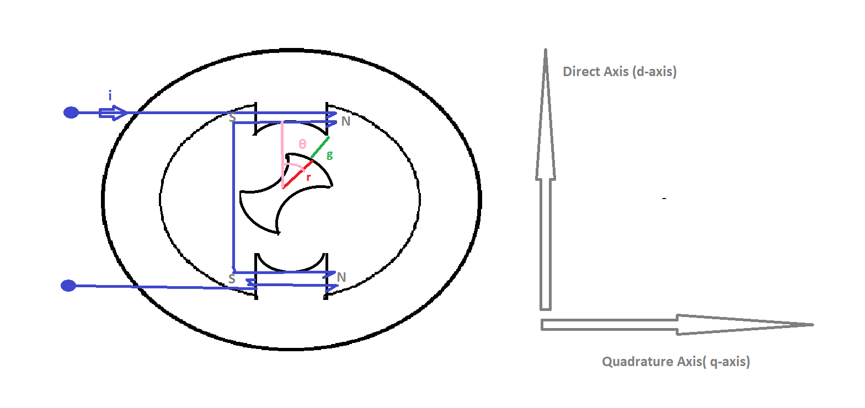

Figure 1 Single-Phase 2-Pole Reluctance Motor

When θ is zero, the effective air gap is minimum. So, reluctance is minimum and inductance is maximum. This inductance is called Ld.

When θ is 90 degree, the effective air gap is maximum. So, reluctance is maximum and inductance is minimum. This inductance is called Lq.

Assume that A is area per pole and A is constant for the every θ and permeability of gap is vacuum value. In addition, all reluctance of the magnetic circuit is in the gap.

L(θ) = 0.5(Ld+Lq) +0.5(Ld-Lq)\*cos(2θ)

The formula X shows change in inductance with respect to θ. The motor is excited by 100 turn coil carries 2 A.

1. When θ is zero, effective air gap is 1 mm and A= 10 cm^2.

Calculate reluctance and inductance.

1. When θ is 90-degree, effective air gap is 10mm and A=100mm^2

Calculate reluctance and inductance.

1. Plot inductance of the motor with respect to displacement angle.
2. Plot electrical torque of the motor with respect to displacement angle.
3. Assume that initial position(ẟ) of the motor is 30-degree and mechanical speed wm=377 rad/sec. Find the electrical torque. ( θ=t\*wm + ẟ). How the average torque is?
4. If the excitation current is alternative current, how does electrical torque changes? Comment the effect of source angular frequency ,mechanical angular frequency and initial position on average torque.